Database architecture discussion

Name of student

Name of professor

University

Course

Date

For my project, am building the Estate security application. I plan to run the application on both mobile application and then also on web application.

The architecture design for this particular application looks as follows and below:

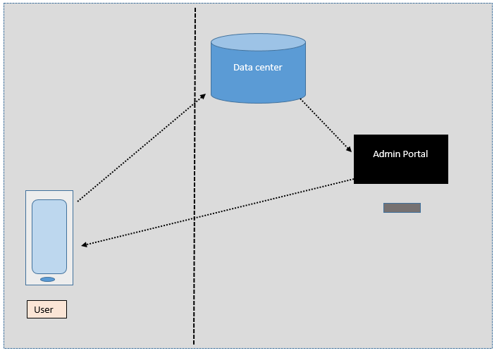

The architecture of this application is based on three major components that include the user device, the database and the admin user portal for manipulating the dB records. Between the use device and the database is an API that connects the two applications together through a seamless communication protocol.

The database properties for this applications are as follows:

**Hosting:**

The application will be hosted on a Linux server environment with access to postgres database type. Reason for use of postegres I that its easier to manipulate records and supports most applications easily.

**Data type:**

The database intended for use in this project relies on the use of structured database types that capture rows and columns of data. This is easier to query and use.

**Security:**

The security of the database is left in the hands of the cloud service provide, however activities such as strong encryption algorithms, regular backups and privilege level access have also been implemented as well.